|  |  |  |
| --- | --- | --- |
| Método | Return value | Priority Queue |
| Insert(5,A) |  | {(5,A)} |
| Insert(4,B) |  | {(4,B),(5,A)} |
| Insert(7,F) |  | {(4,B),(5,A)(7,F)} |
| Insert(1,D) |  | {(1,D),(4,B)(5,A),(7,F)} |
| RemoveMin() | (1,D) | {(4,B),(5,A)(7,F)} |
| Insert(3,J) |  | {(3,J)(4,B),(5,A)(7,F)} |
| Insert(6,L) |  | {(3,J),(4,B),(5,A),(6,L)(7,F)} |
| RemoveMin() | (3,J) | {(4,B)(5,A),(6,L)(7,F)} |
| RemoveMin() | (4,B) | {(5,A),(6,L)(7,F)} |
| Insert(8,g) |  | {(5,A)(6,L),(7,F),(8,g)} |
| RemoveMin() | (5,A) | {(6,L),(7,F)(8,g)} |
| Insert(2,H) |  | {(2,H)(6,L),(7,F)(8,g)} |
| RemoveMin() | (2,H) | {(6,L),(7,F)(8,g)} |
| RemoveMin() | (6,L) | {(6,L),(7,F)(8,g)} |

Ejercicio 9.3

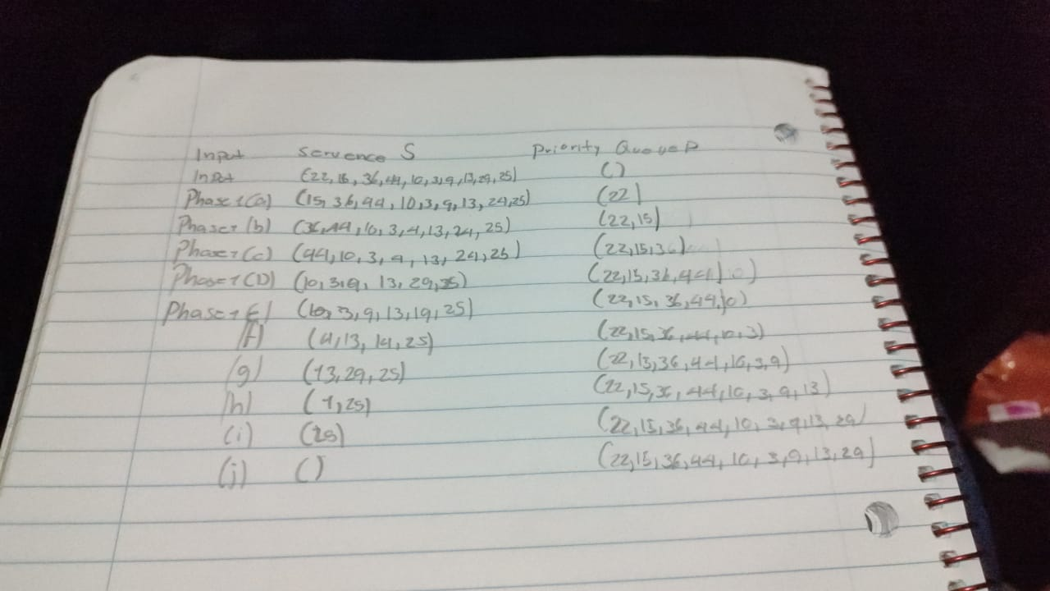Ejercicio 9.7

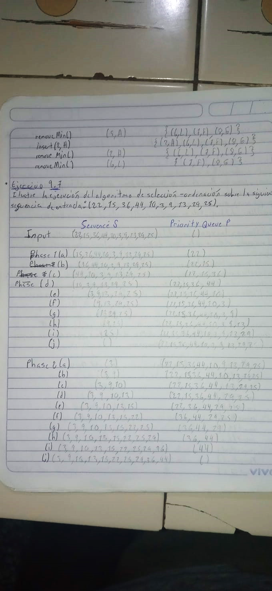

Ejercicio 9.22